Marketing Your Awards Program

& Sample Communications

Marketing Your Program
The first step to marketing your awards program is to identify a few key factors:
- Who is your audience (who will be applying or nominating?)
  - Are you targeting professionals who are eligible for the awards?
  - Are you targeting the groups that will likely recommend and/or nominate their colleagues for awards (ex. supervisors, program managers, directors)? Or encouraging individuals to nominate themselves?
- What are their incentives to nominate/apply?
  - Draw attention to their programs, schools, colleagues
  - Be a part of the state-wide, Region-wide, or nation-wide campaign to recognize excellence in CTE
- What information do they need in order to participate in the program?
  - What the award is and its purpose
  - Who is eligible
  - How to apply
  - Deadline to submit an application/nomination
  - When winners will be announced/recognized
  - Who to contact with questions
- What venues or channels can you use to market your program to your audiences?
  - Website(s)
  - Newsletters
  - Flyers & Brochures
  - Social Media (twitter, Facebook, pinterest)
  - Conferences
  - Word of mouth

Key Messages
It’s important to remember that any messaging about your awards program is a reflection of your organization and the program. Sample messages regarding various stages of the awards and recognition process are available on the next few pages for your reference.

1. Call to entry
Your call to entry announces that your program is open for nominations. Ideally, you want to announce your call to entry at least 3 months before your deadline, and you want to make sure you communicate this information more than once (send reminders). Your call to entry needs to include all of the information people need in order to nominate or apply for an award (see above).

SAMPLES:
Is there a secret CTE hero in your school or community?
Help us bring the best in CTE out into the spotlight by nominating someone for a Virginia ACTE Member Award! The Member Awards bring well-deserved prestige and recognition to members across the country for their innovation and dedication to career and technical education. Virginia ACTE is conducting a statewide search for the following:

Teacher of the Year Postsecondary Teacher of the Year
New Teacher of the Year Career Guidance Award Administrator of the Year
Carl Perkins Community Service Award Lifetime Achievement Award

Recognizing the best in CTE starts with YOU! Nominations are due by January 15 and can be submitted online here. All candidates must be VACTE members. Visit our webpage for more information on the awards and eligibility requirements. Winners will be announced and recognized during the 2015 VACTE conference. If you have questions, contact awards@acteonline.org.

NOW is the time to recognize excellence in CTE!
Don’t miss your opportunity to nominate yourself or a colleague for an ACTE Member Award! The Virginia ACTE Awards celebrate the very best in CTE among our association members. Virginia ACTE is now accepting nominations for the following:

Teacher of the Year Postsecondary Teacher of the Year
New Teacher of the Year Career Guidance Award Administrator of the Year
Carl Perkins Community Service Award Lifetime Achievement Award

The January 15 deadline is right around the corner! To learn more about the Virginia ACTE
Awards and to submit a nomination, visit our webpage. All applications should be submitted
online via the ACTE Awards Portal. For questions, please contact awards@acteonline.org.

2. Following up with Candidates:
After the deadline to nominate closes, it’s a nice idea to email all of those who applied or nominated someone for an award to let them know what the next steps are (whether or not they will be interviewed, when the winners will be announced, etc.)

If you will be recognizing all nominees during an awards ceremony or meeting at your state conference, this is also a good opportunity to formally invite your participants to that event. Make sure to include the pertinent details about the event (when & where, if there is a fee for award nominees/guests, dress code, if there is a rehearsal beforehand).

SAMPLE:
Schedule & Information for [State] ACTE Award Nominees

On behalf of ACTE, congratulations on your nomination for a [State] ACTE Award! All award nominees and winners will be recognized at our Awards Banquet in [city, state] in conjunction with the [state] ACTE conference on [date] from [time]. All events listed below will take place in the [venue] [address].

WEDNESDAY, NOVEMBER 19th
All activities on Wednesday will take place in Presidential Ballroom D.
TIME | EVENT | ATTENDEES
3:00-4:00 p.m. | Awards Banquet Rehearsal | ALL national & Region award winners; sponsor representatives & speakers
6:30 p.m. | Banquet check-in opens | **recommended that award winners check in early**
7:00-9:00 p.m. | ACTE Awards Banquet | ALL national & Region award winners; sponsor representatives & speakers; Banquet guests

ACTE Awards Banquet information:
During the 2014 ACTE Awards Banquet, ACTE will recognize the national Image Award winners, all Region Member Award winners, and announce the national winners for each Member Awards category. The event will feature a three-course meal, entertainment and guest speakers. Formal business attire is requested—please wear something you would be comfortable having your photo taken in. Registration is complimentary for all Region and national winners. Guest tickets are $85 and the deadline to register is November 12th. Learn more about the Awards Banquet at www.acteonline.org/vision_banquet.

Do I need to register for the Awards Banquet?
No, you do not. As an award winner, you will receive one complimentary Awards Banquet ticket. If you would like to purchase a ticket for a guest, you can do so in conjunction with your VISION registration here. Your complimentary ticket will be processed after your VISION registration is received. If you do not plan to register for VISION but plan to attend the Banquet, please let us know so we can move forward with processing your complimentary ticket.

Does ACTE provide any travel stipend for award winners to attend VISION?
Unfortunately, ACTE does not have the funds to bring all of its award finalists and winners to VISION. National winners will be comp’d their VISION registration after the winners are announced (national Member Award winners will be reimbursed their fees following the winner announcement). If you need help requesting leave or funding from your school to attend VISION, ACTE has a sample letter of justification available on our website here.

If you have any questions, please contact Kate Dowdy (kdowdy@acteonline.org). We look forward to seeing you in Nashville!

3. Invitation to Awards Ceremony
Don’t forget to invite your other members to attend the awards ceremony! Details to include: when, where, cost, dress code, some basic information about the event (who will be recognized, what the awards are for), deadline to RSVP/purchase a ticket, sponsor acknowledgement. See a sample promotion for the ACTE Awards Banquet below.
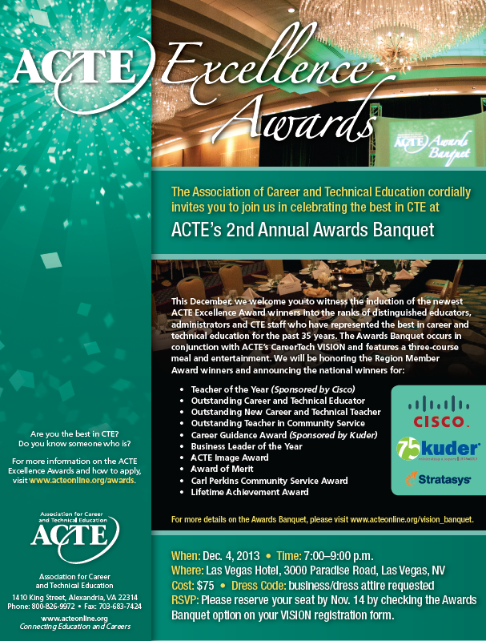

4. Next Steps for Winners
After congratulating your winners at your awards ceremony, you will want to follow up with some next steps about the process for consideration at the Region level (also note: your winners will need to know they must be members of ACTE national by the March 1 deadline in order to qualify. If your state is non-unified, please be sure to communicate that detail to your winners).

SAMPLE:
Hello [State] ACTE award winners,

Congratulations on being named the [State] ACTE award winners in your categories! Your selection is a testament to your dedication, commitment and passion for career and technical education, and we are proud to include you among the ranks of distinguished educators, administrators, and CTE staff alongside whom you have been chosen to represent the best in career and technical education.

As you may know, your win at the state level qualifies you as a finalist in Region XX, and your applications will be moved forward for consideration by the ACTE Region XX Awards Committee. You will receive more information about the Region review process in the spring.

[If your state used the Awards Portal, this is a good opportunity to grant them access to edit their applications and give them a deadline for updating apps (must be completed for Regions by March 1).

If your state did NOT use the Awards Portal, please send your winners the link to submit their applications on the online system (https://acte.nonprofitcms.org/a/page/awards/regions) with a deadline of March 1.]

If you have any questions about the next steps in this process, please contact XX.

Attached is a press release announcement—we encourage you to share this news with your colleagues, peers, and fellow members! The press release can also be viewed on our website here: XX.

Sincerely,

5. Message to Non-Winner (and/or nominators)
It’s nice to send an acknowledgement to those individuals who did not win to thank them for their participation in the program. Some samples are included on the next page.

SAMPLES:
(self-nomination)
Dear XX,

Thank you for submitting your application for the ACTE XX award. Unfortunately, your application was not selected to move forward for national awards consideration. We are so appreciative of the work you are doing, and we hope that members like you will continue to bring outstanding work in CTE to our attention and continue to further your involvement in the Association. If you have any questions about awards or are interested in learning more about opportunities for dedicated members such as yourself to get involved in our association, please contact XX.

Sincerely,

(nominated by a peer/member):
Dear XX,

Thank you for submitting your nomination of XX for the ACTEXX Award. Unfortunately, your candidate was not chosen to receive this award, but we would like you to know that the Awards Committee was very impressed with the quality and number of applications received this year and that many of the decisions made were not easy. Your nomination of this candidate alone is a testament to their dedicated contributions to CTE, and we hope that members like you will continue to bring outstanding work in CTE to our attention. For information on next year’s ACTE Excellence Awards and the Awards Banquet, please visit our website.
Please give our regards to XX and let them know their work is truly appreciated.

Sincerely,

